***DREAMWEAVER THEATER***

*User guide*

|  |  |  |
| --- | --- | --- |
| **Supervisor.** | **Miss Aatika** | |
| **Batch.** | **2109c1** | |
| **Group.** |  | |
| **Serial No.** | **Enrollment Number** | **Student Name** |
| 1. | Student1332444 | M. Taha khan |
| 2. | Student1332448 | Fahad khan |
| 3. | Student1331510 | Hafeez ur rehman |



1. **Home** (*index (1).html*)

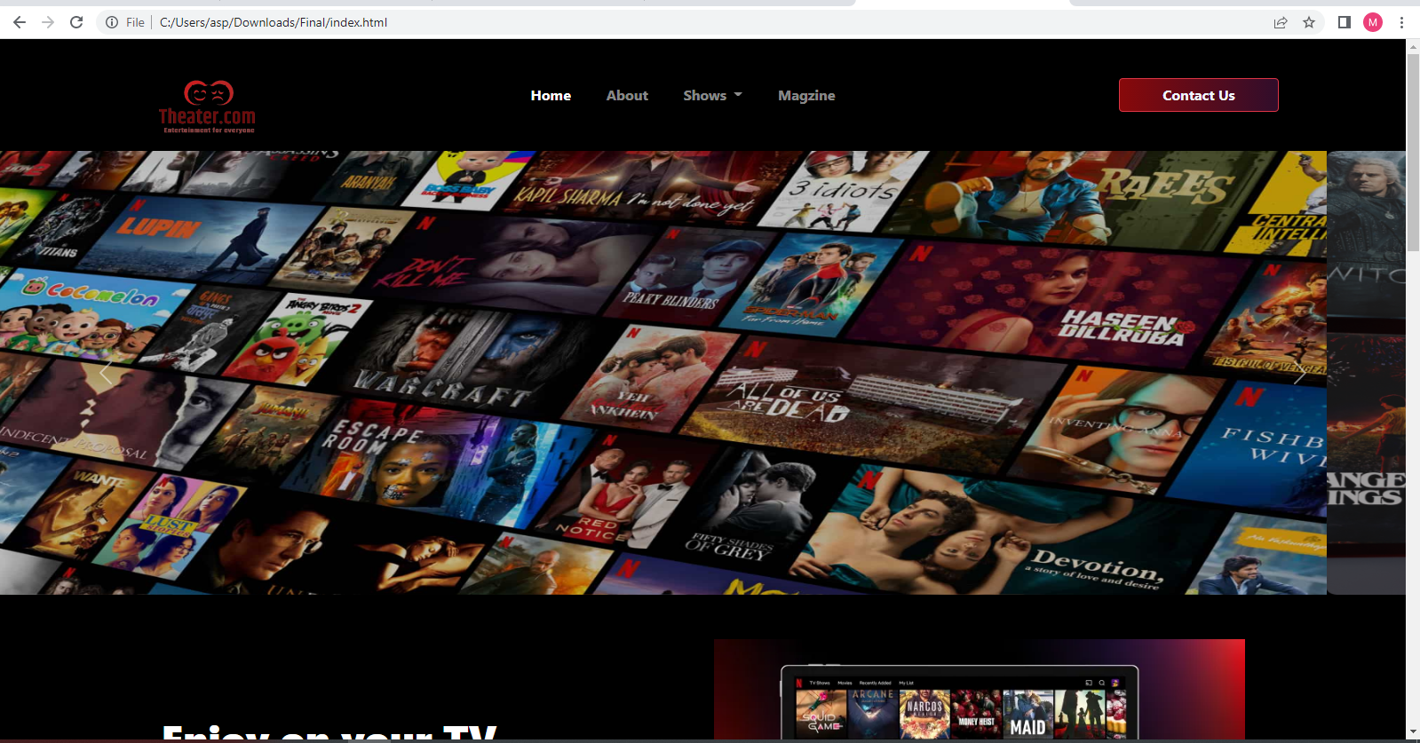

***Figure 1: Home page to Nexus aquarium***

 Our Slogan has given to the peoples toward our website. “DREAMWEAVER THEATER”.

1. **Navbar (index (1).html)**

**

***Figure 2: Navbar***

We have given seven essentials. By clicking any of the essential’s and redirect to the linked page. (0. Index (1).html)

1. **About us (index (1).html)**

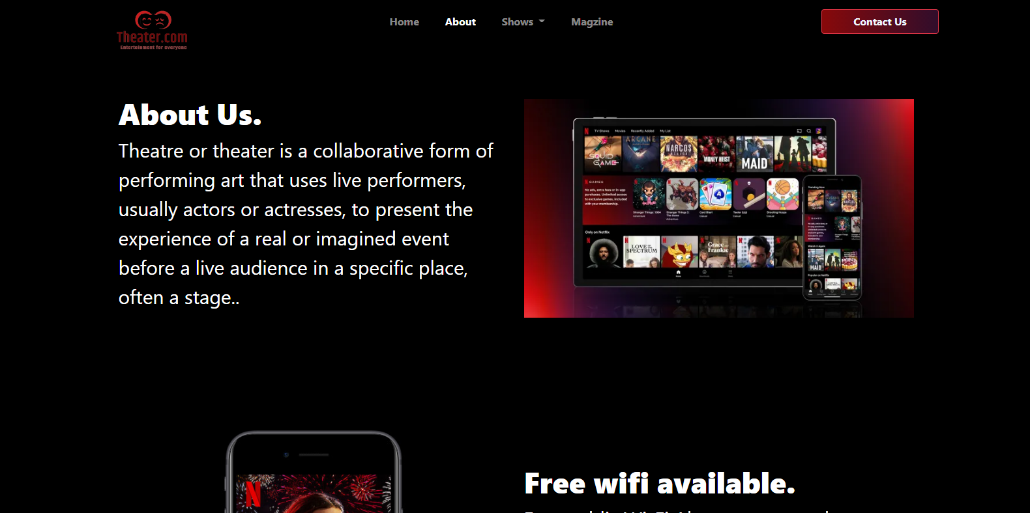

***Figure 3: About us***

**



** ***Wifi services****: We are providing free wifi services to our visitors*

* ***Cleaning Service:*** *We have mentioned that we are providing theater cleaning services to the customer.*

***4.Hindi (index (1).html):***

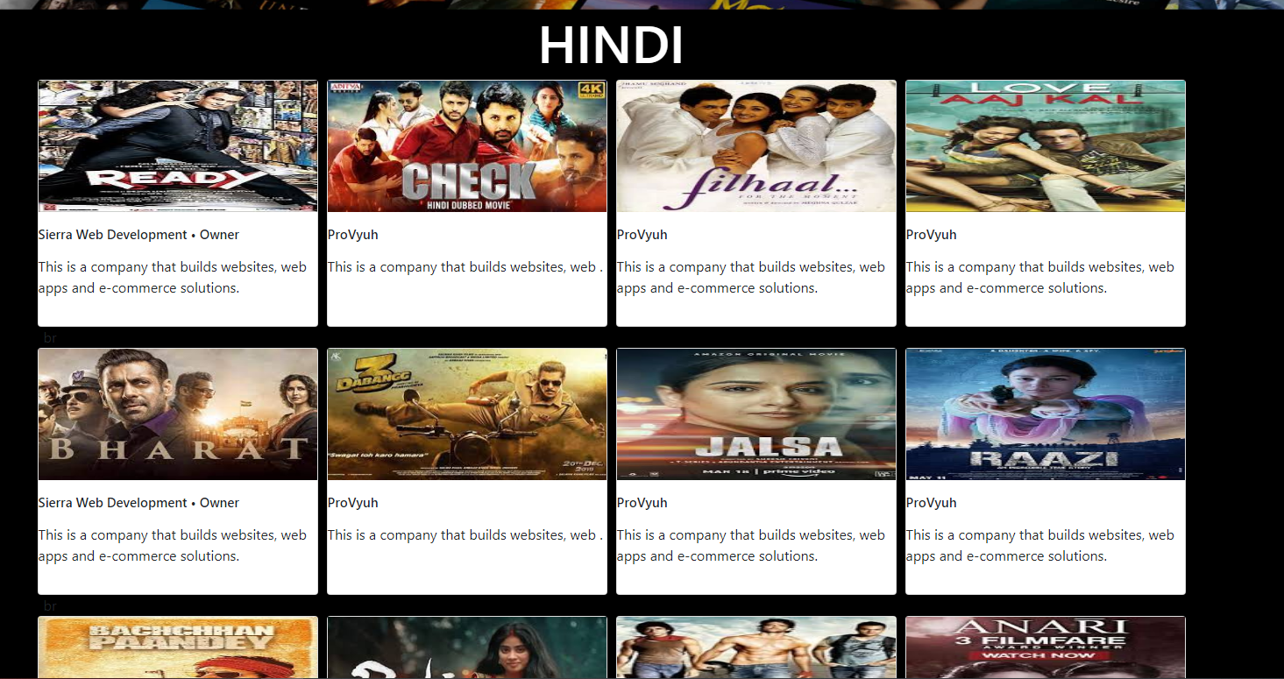

Our page of Hindi shows is designed to elaborate about our Hindi theater shows .

***5.English (index (1).html):***

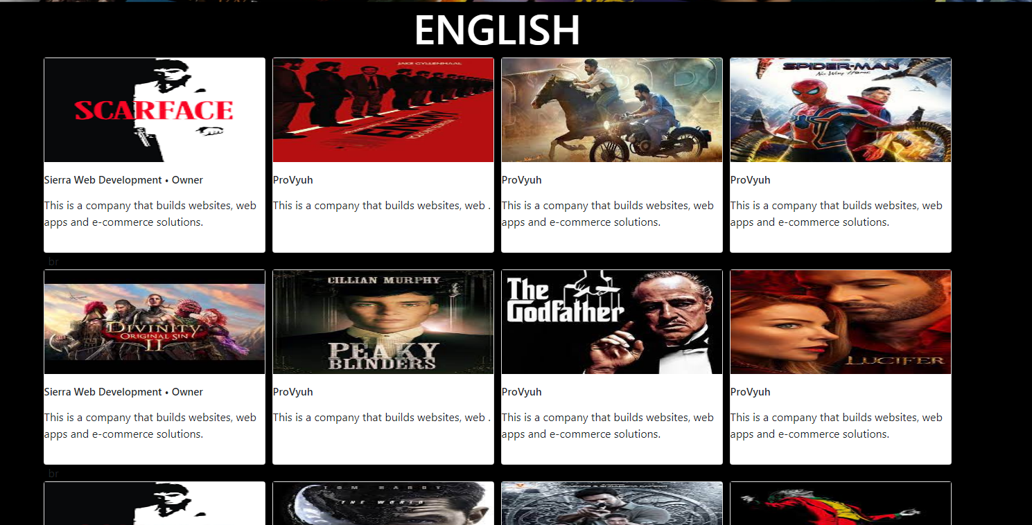

***Figure 5: English***

Our page English shows is designed to elaborate about our English theater shows .

***1.Urdu (index (1).html):***

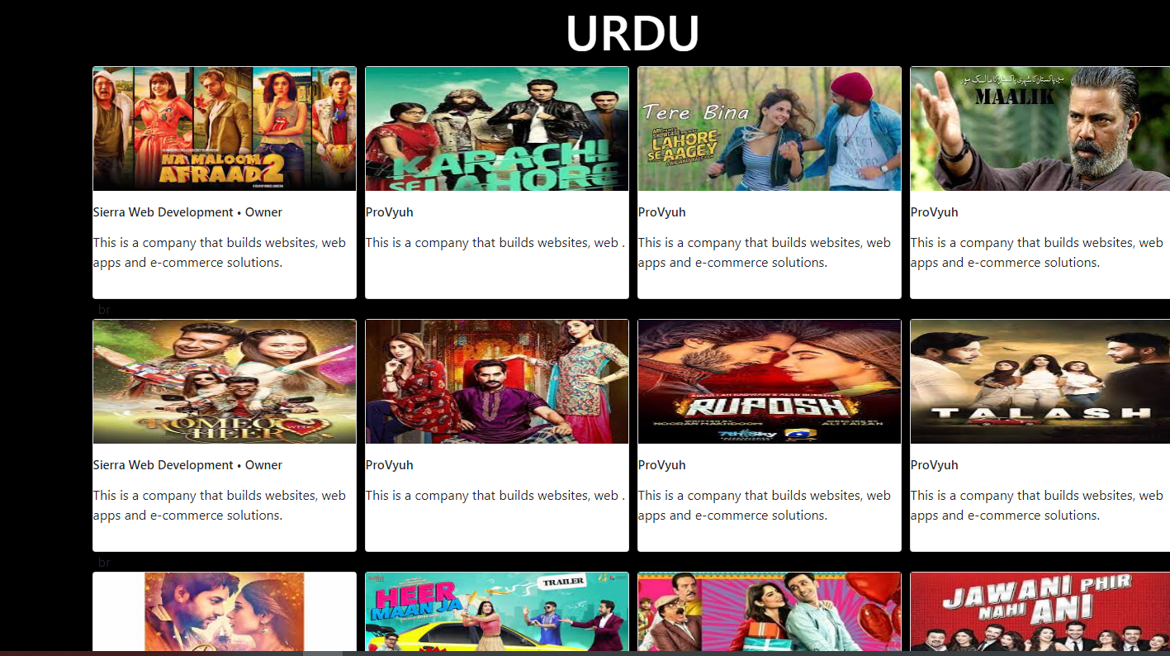

***Figure6 : Urdu***

Our page of urdu shows is designed to elaborate about our Urdu theater shows .

***Figure 7 : Contact form***

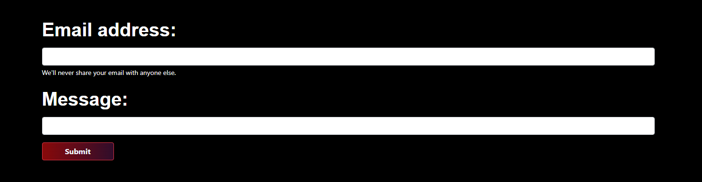

*Contact Form:*

In contact forms customer have to give details:

Your Full Name: Customer have to write their full name.

Your Email: Email won't be accepted without @ we have given validations. Description: Description is optional but if they want to mention any validation or request about something they can write there.

9.***Questions About Theater (index (1).html):***

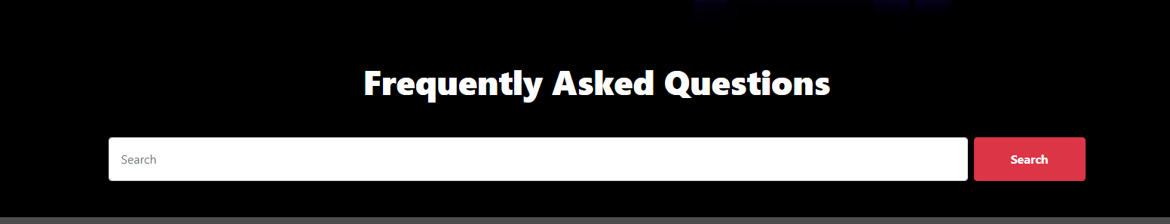

***Figure 8: Questions about Aquarium***

If any client has any query about our theater shows or our theater so they can have solutions over here

10.***Footer About Theater (index (1).html):***

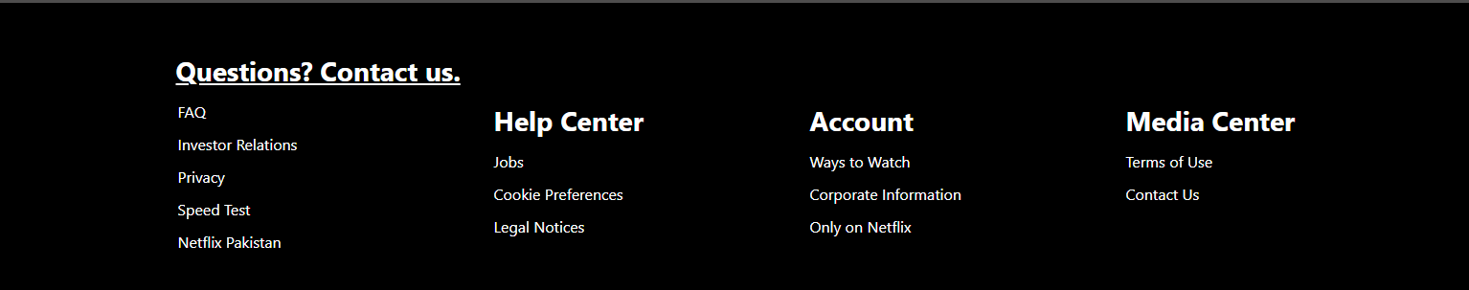

***Figure 9: Footer***

We have given some animations in footer to make our website more relaxing.

